South China University of Technology
《Computer Organization and Architecture》Experiment Report
Experiment Title： Micro-Controller
Name： 谭演锋Student ID： 202130100456
Class： Group：
Collaborator：
Teacher： 毛爱华
Description
【Objective and Requirement】
Objective
(1) Understand the concept of “micro-program”, know the “instruction -microinstruction -microcommand” style of micro-program structure.
(2) Master the organization structure and design method of micro-controller.

Requirement
Design a minimum prototype of CPU: generate the schemed CPU time sequence with sequence generator, and use the auto-control of micro-controller to achieve the particular CPU function ——Program Jumping.

【Environment】
Operating System：Windows XP
Content
【Procedure】
- Step：
Exp1: Jum1 and Jum2
According to the code below, compile and make the hex files and burn them into EPROM1, EPROM2, EPROM3 seperatively(WARNING: DO NOT MESS IT).
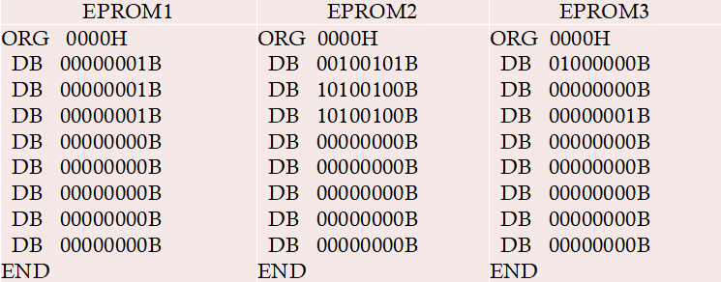
Compile the code below and burn it into PROGRAM module.
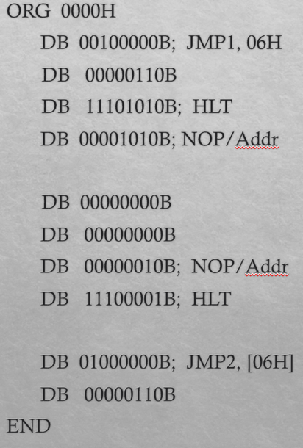
Before start, swtich CLK to MANUAL_CLK; Start simulation, make RESET=1, manually press MANUAL_CLK to make CLK rising-edge transit. Initial {T1,T2,T3,T4}={1,0,0,0}; MAKE RESET=0 and the initial process complete.
Press MANUAL_CLK and make CLK pulse as“ ”, step over the above program. In the instruction cycle of Jum1 and Jum2, compare to workflow of _ ,observe the function of micro-instruction and the stepping result( data of AR,IR,PC,BUS).
Switch CLK to AUTO_CLK(10hz)，the program will run to HLT break point and pause. Look into the number of micro-instruction cycles in break point and the result data of AR,IR,PC,BUS. Then enable RESET as “0->1->0”, jump out break point and run the next instruction
Exp2: Jum3
Add a new jump instruction Jum3 as below. Supply the micro-program workflow and micro-instruction code table. Implement the function of Jum3
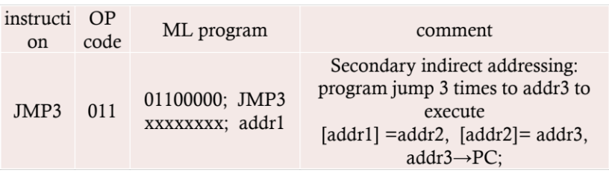
Compile the code to hex file and burn it to PROGRAM.
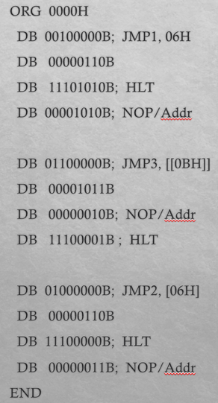
Refer to the initial process and step over method of exp1, repeat the experiment and observe the result data.
Refer to the method of auto-run and jumping out of break point in exp1, auto run the program, observe the micro-instruction cycles in break point and the data of AR,IR,PC,BUS.

- Data：
Micro-instruction code table
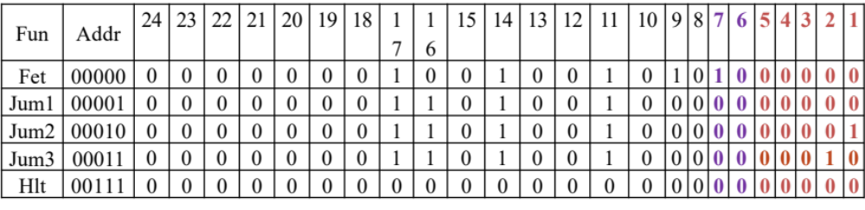

- Major Procedure：
Exp1: Jum1 and Jum2
- Press MANUAL_CLK and make CLK pulse as“”, step over the above program. In the instruction cycle of Jum1 and Jum2, compare to workflow of _ ,observe the function of micro-instruction and the stepping result( data of AR,IR,PC,BUS).
Jum1:
- T1 period:
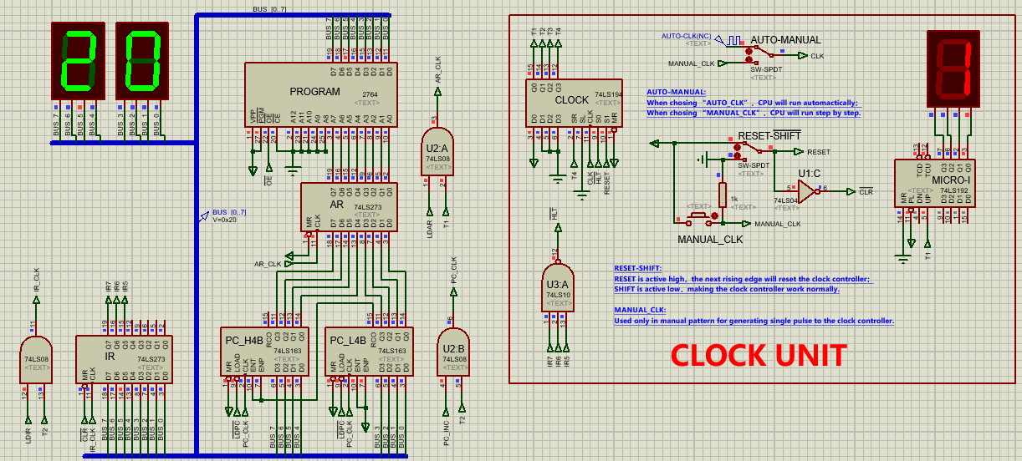
Explainion: The first instruction of the CPU is fetch. So first the CPU will read the first address from the PROGRAM.
PC -> AR ROM→BUS LDAR: 1
PC is equal to 0. LDAR=1 so load the data from PC to the AR which is 0. So we will read the instruction which address is 0 in the PROGRAM to the BUS. Which is 00100000B = 20H
- T2 period:
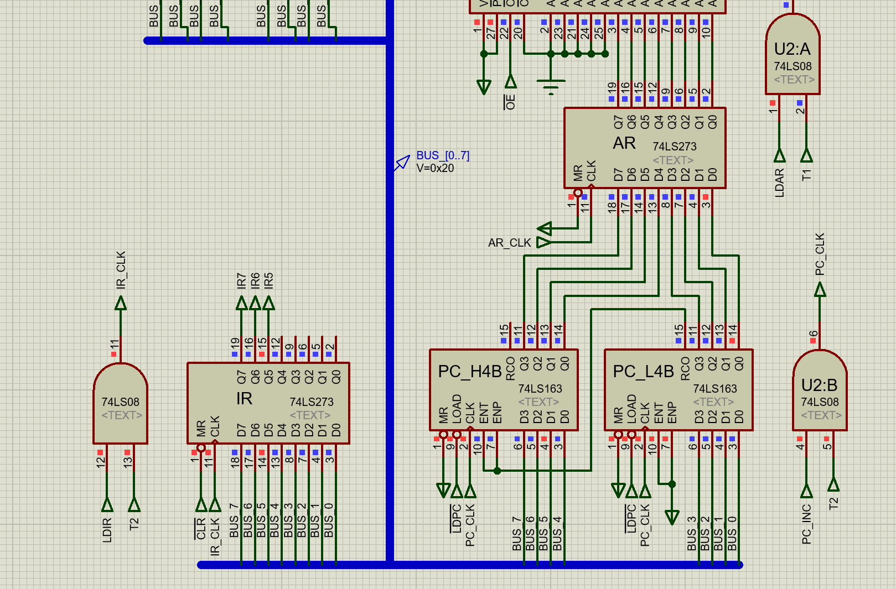
Explainion: In the T2 period, we do the operation of BUS->IR, PC+1. LDIR =1, The data from BUS is loaded into the IR and send to the Countrol unit by IR7, IR6, IR5.Then the PC_CLK=1, So PC adds 1.
- T3 period:
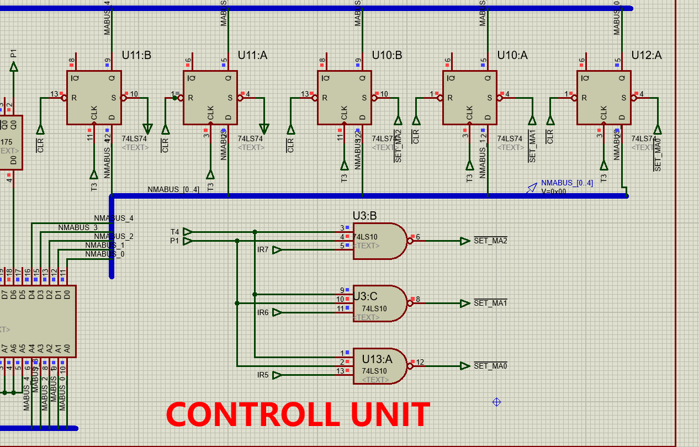
Explainion: In the T3 period, we Fetch micro-address by the Max to read the Micro-instruction code in the T4 period. Be careful that, we do not get the micro-address in this period, instead we will get the micro-address in the next period T4.

- T4 period: Micro-address change to 00001 (the address of the jump instruction)
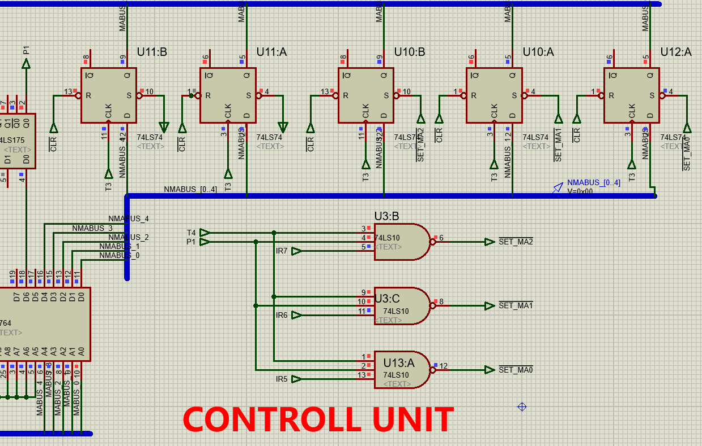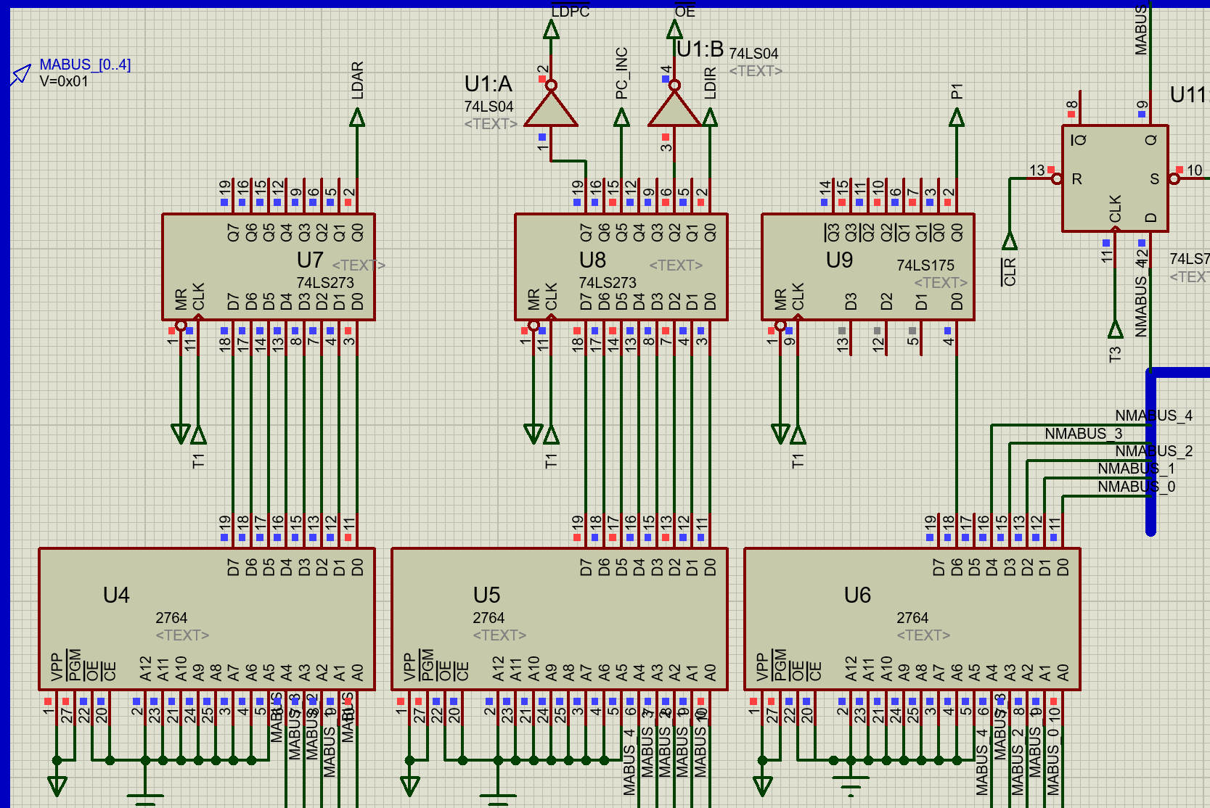
Explainion: In the T4 period, we Fetch micro-instruction according to the micro-address in the MROMx. Then we will send the control signal to control the CPU.
- The second T1 period:
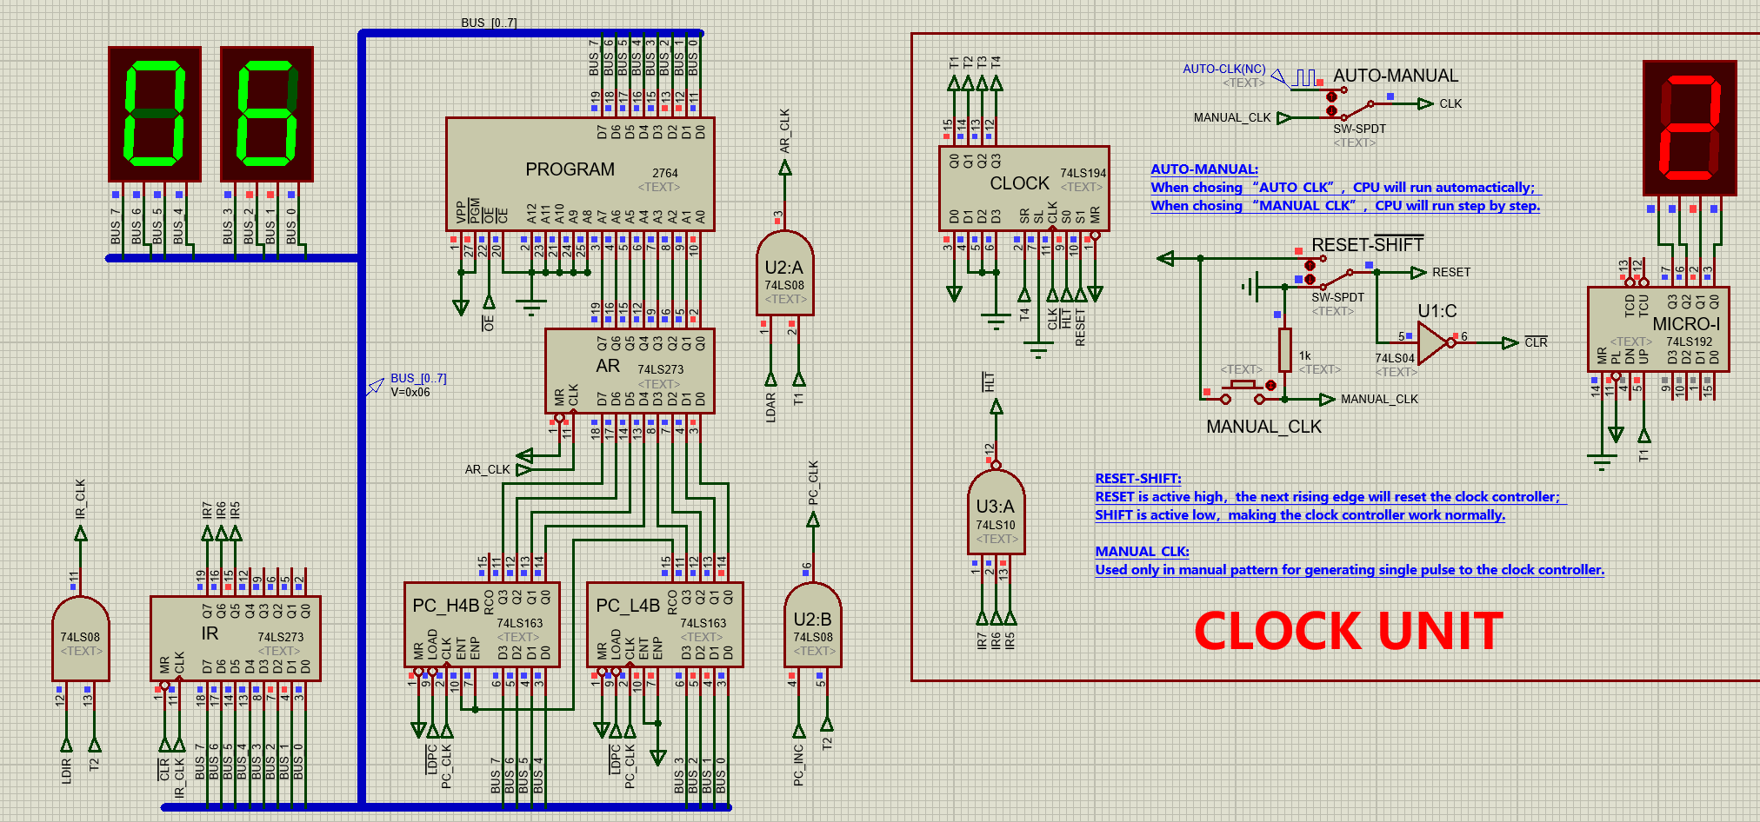
Explainion: In the second T1 period, PC -> AR ROM→BUS. At this time the PC=1, so the AR=1. PROGRAM load the instruction in address 1 which is “00000110B” = “06H”. To the bus.
- The second T2 period:
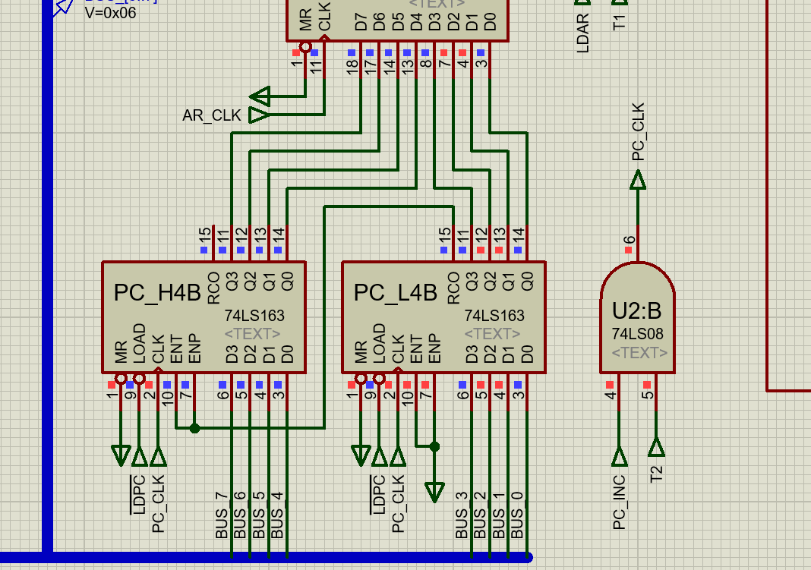
Explainion: In the second T2 period, since LDPC=0, which is controlled by the micro-instruction. So the data in BUS = “06H” is loaded into the PC no matter whether the PC increase or not. Finally at this time the CPU instruction jumped to “06H”.
- The second T3 and T4 period:
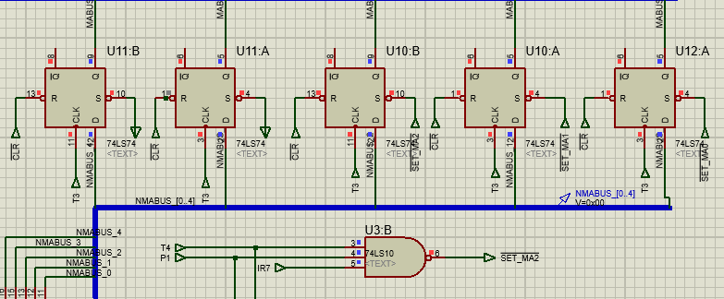
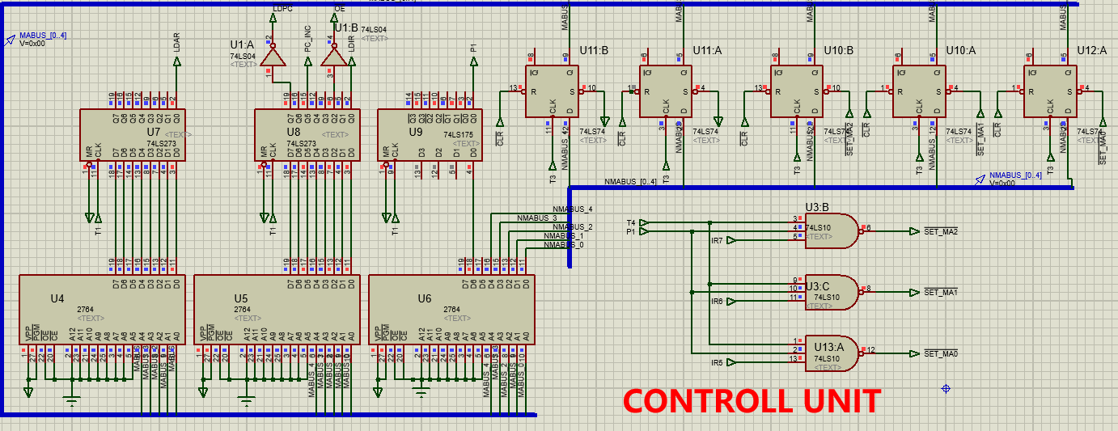
Explainion: In the second T3 and T4 period. The Max send the micor-address according to the U-address of last micro-instruction(Ju,1) which is equal to “00000” which means the next control signal is the Fet. i.e Fectch the next instruction of the address “06H”.

Finally the Jum1 instruction finnish.
Jum2:
Explainion: The process of the Jum2 is very similar to the Jum1. One of the major difference is the caused by the micro-instruction code of U-address.
After the Machine cycle of running Jum2. We can get the address of instruction in PC =“06H”. The in the second Machine cycle of running Jum2, we will run the micro-instrction in the address “00001” according to the U-address which is the Jum1 micro-intruction. Therefore, agagin we will read the data in PROGRAM of address “06H” which is “00000010B” = “02H”, which means we finally jump to “02H”. Then the finally and the next micro instruction is Fec.

- Switch CLK to AUTO_CLK(10hz)，the program will run to HLT break point and pause. Look into the number of micro-instruction cycles in break point and the result data of AR,IR,PC,BUS. Then enable RESET as “0->1->0”, jump out break point and run the next instruction
The LED light shows 20 at the beginning and continues to the end of E1(HLT). Complete the jump of 4 micro-instructions.
LED light display sequence is 20 -> 06 -> 02 -> E1.
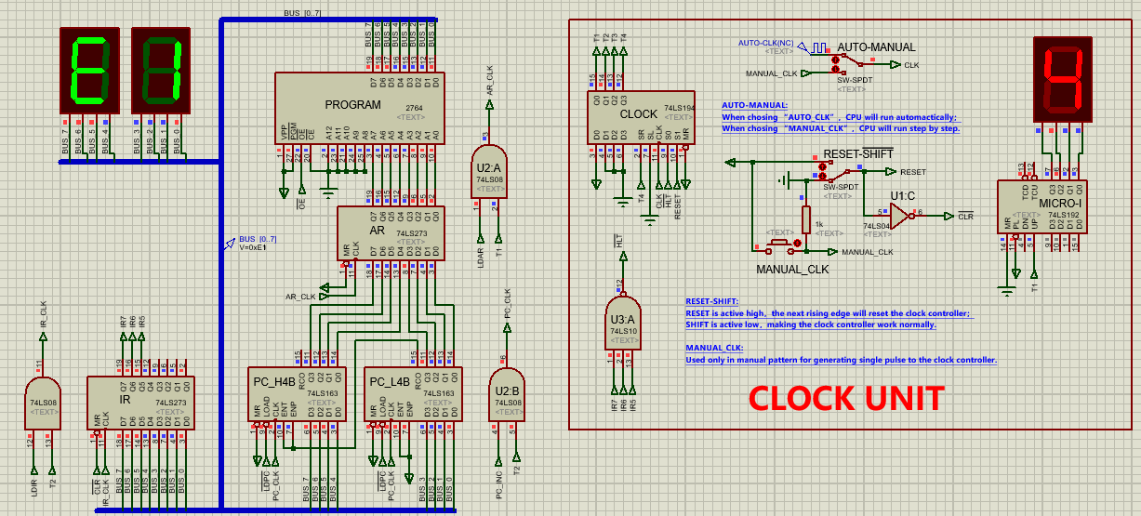
Explaination：At first the program run “00100000B”, which represent “02H”， so the LED display “20” which represent the jump order. Then the program run “00000110B”, which means the program jump to the “06H”, the LED display “06”. So the program wil jump to the address of “06H” to PC. Then the program read the instructuon in the address “06H” which is the “00000010B”, which represent “02H” and LED display “02”. This inturstion is NOP. Then the program read the next instruction “11100001B”, which represent which represent “E1H” and LED display “E1”. This inturstion is HLT. Therefore, the program halt.

Then enable RESET as “0->1->0”, jump out break point and run the next instruction
The LED light display order: 40 -> 06 -> 02 -> EA.
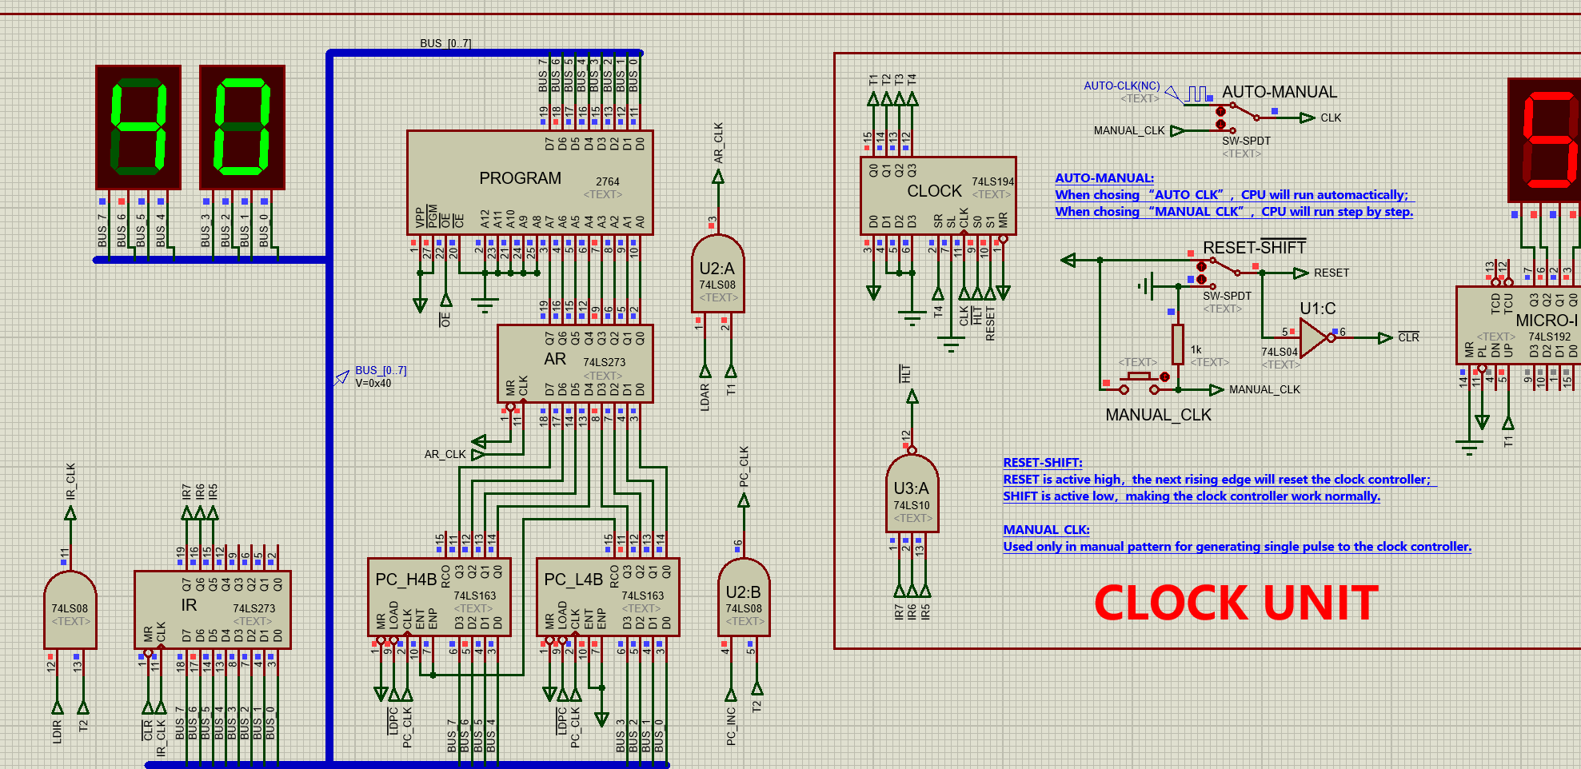
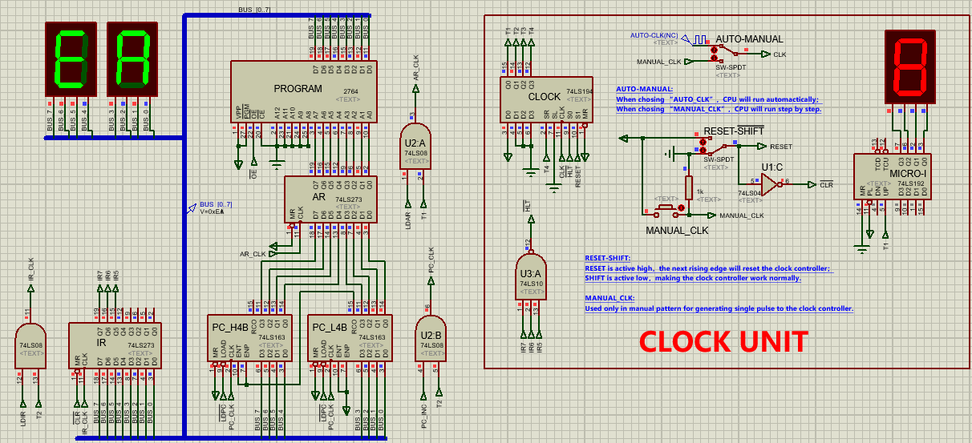
Explaination: At first the program run “01000000B”, which represent “40H”，so the LED display “40” which represent the jump order. Then the program run “00000110B”, which means the program jump to the “06H”, the LED display “06”. So the program will read the conent in “06H”, which is the “00000010B”, which represent “02H” and LED display “02”. Then the “02H” is loaded in to PC. Finally the program will read the instruction in “02H”, which is “11101010B”, which represent which represent “EAH” and LED display “EA”. This inturstion is HLT. Therefore, the program halt.

The whole LED light sequence is: 20 -> 06 -> 02 -> E1 -> 40 -> 06 -> 02 -> EA.

Exp2: Jum3
Add a new jump instruction Jum3 as below. Supply the micro-program workflow and micro-instruction code table. Implement the function of Jum3
Workflow and micro-instruction code:

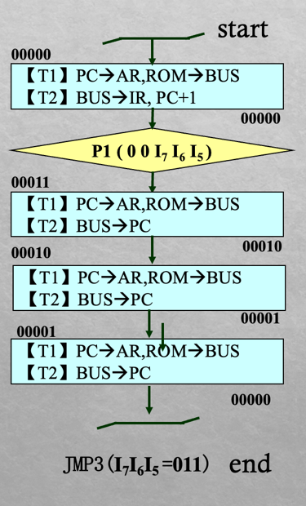
- Re-burn EPROM and PROGRAM, so that we can achieve Jum3 operation.
- Refer to the initial process and step over method of exp1, repeat the experiment and observe the result data.
Explainion: The process of the Jum3 is very similar to the Jum1 and Jum2. One of the major difference is the caused by the micro-instruction code of U-address.
From the table we can find that control first implement Jum3 then Jum2 and finally Jum1. Therefore, we achiceve Indirect address 3 times. Form “0BH” to “03H” and finally “0AH”.
- Refer to the method of auto-run and jumping out of break point in exp1, auto run the program, observe the micro-instruction cycles in break point and the data of AR, IR, PC, BUS.
Performing the same operation as Exp1, the first eight instruction displays the same. Start with EA's next instruction:
The complete display sequence of LED light is: 20 -> 06 -> 02 -> E1 -> 40 -> 06 -> 02 -> EA -> 0A -> 60 -> 0B -> 03 -> 0A -> E0.
Performing the same operation as Exp1, the first eight instruction displays the same. Start with EA's next instruction:
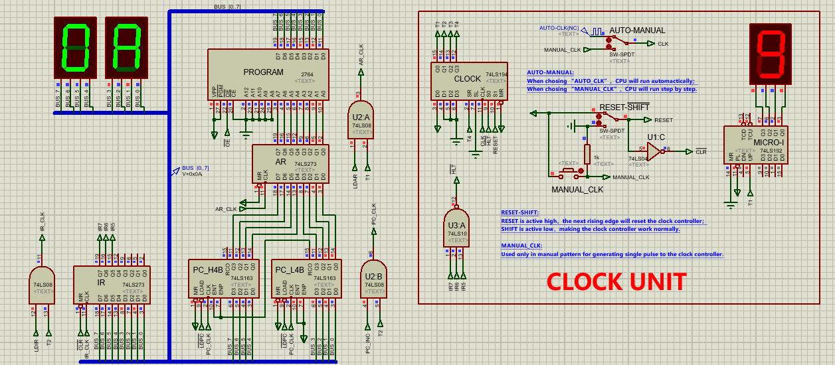
Finally, the E0(HLT) program is paused.
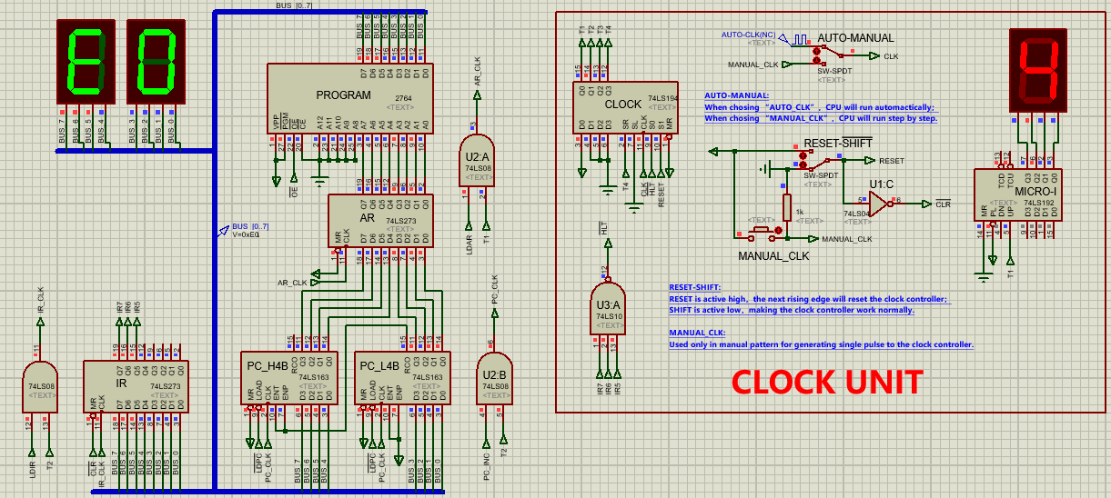
Explaination：At first the instruction at 0x0A operates on NOP/Addr, so execute the instruction 0x60 on the next line: Jum3 [[0BH]]. Jum3 completes three jumps: First jump from 0x0B to 0x03 on line 11(B). Then jump to 0x0A on line 3. Finally to E0 on line 10(A), and finally executes the operation of HLT at the instruction position of 0xE0 and the program pauses.

- Question：
Question1: In the micro-instruction table, [00001] and [00010]’s operation
is completely same.So, can we merge these two instructions? If not,why?
No. One is a direct addressing and the other is an indirect. They have different Micro-instructioncode.
The last 6 bits of the U-address are different, which is used to identify where the next Micro-instructioncode is to achieve the indirect instruction.
Question2: In this experiment’s program, some addresses is annotated as “NOP/[ADDR]”. What’s the difference of NOP and NOP/[ADDR]? Under what situation it will do nothing or jump the program?
NOP means no operation, which means this instruction do nothing in the CPU. However the NOP/[ADDR] means the instruction in the memory can be no operation or the address, which determine by what is the last instruction. If the last instruction is Jum, which is the indirect address, the instruction is viewed as an address stored in th memory. Otherwise, if we load the instruction by PC+1, the instruction means no operation.
Conclusion
After finishing the experiment I have a deeper understanding of how the CPU work by the implementation of component IR, MAR, RAM, PC and Control Unit. I also depper understand how the CLK as time period to control the work of the CPU. The CLK in diffenret period will send different control signal to control the work of the component in CPU I have learned that the MAR is used as a transfer station of PC and RAM, which is used to get the instruction from RAM by the address provided by PC. Besides, I learn how the IR work, which is used to received instruction provided by RAM and then send the control signal to the control unit to get the micro-address to get the micro-instruction code. Most importantly, I have learned how the control unit work to send the control signal to control the function of the CPU. It send the micro-instruction according to the micro-address. Micro-instruction is used to represend the control signal to control different part of the such as PC and IR to work. Micro-instruction is also used to get the address of next micor-instruction.
Teacher’s Comments and Score
Comment：

Score： Signature：
Date：

